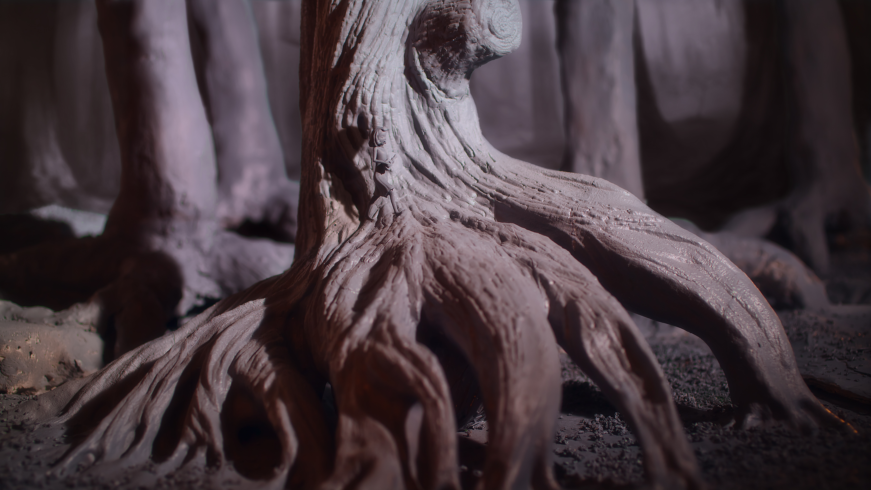
Chase Me

Artist creates film made entirely of 3D printed parts
Gilles-Alexandre Deschaud spent two years creating the stop-motion animation film, Chase Me, from 2,500 3D-printed pieces.
The story begins with a girl walking through a magical forest. During her stroll, her shadow evolves into a monster who chases her through the woods. “Chase Me is a story about embracing your fears, and turning them into something beautiful,” says Gilles-Alexandre.
Every frame of the film was first designed by the artist in CG, before being processed into 3D prints. The mise-en-scene was then recreated through stop-motion animation (15 frames per second) to produce the film’s final result.
The set and characters for Chase Me were printed in 100 micron resolution, with minimal finishing beyond the removal of the support material. Bigger pieces, like the tree in the forest, were printed in 22 individual parts, then assembled.

For more information on screenings and details about the film, visit http://chasemefilm.com.

About Gilles-Alexandre Deschaud
Gilles-Alexandre Deschaud has been working in the VFX industry as a digital artist and animator for the past 7 years. Throughout his career, he has experimented with various animation techniques, using a hybrid of 2D mediums, such as painting and drawing, combined with 3D animation. His experimentation with new styles led him to discover 3D printing as a means of video creation. Gilles-Alexandre’s latest project is Chase Me, a stop-motion film that was entirely 3D printed

Synopsis

In an enchanted world, a young girl is walking and singing while playing ukulele.
Heedless of the outside world, she does not pay attention to the approaching threat.
Her own shadow starts to come alive, to tear off from the ground and to chase her.

Synopsis d'une ligne

This short film follows a ukelele-playing girl who is chased through a dark forest by the monster that emerges from her own shadow.

Filmographie :

It's my first short movie, but I was co-director on personal movie clip : ghost are dancing :
https://vimeo.com/52306302

Official Website :

http://www.chasemefilm.com/

