Sélections Officielles “ (LITTLE) RED RIDING HOOD ”

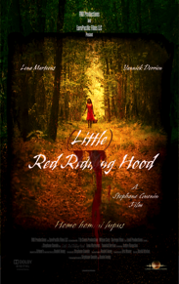

2015
Odisha Kids International Film Festival (Indes)
Chinh Kids Film Festival (Indes)
IV Inter.Fantastic and Horror Film Festival of Navarra (Espagne) – Best Foreign Short Film 
Oregon Underground Film Festival (Usa)
Chelsea Film Festival (Usa)

2016
Texas Ultra Shorts (Usa) – Best International Horror Short Short Award 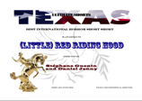
IChill Festival (Philippines)
The Brightside Tavern Shorts Fest (Usa)
Madeira Film Festival (Portugal) – Laurissilva Forest Award 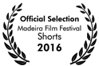
12 Months Film Festival (Roumanie) – Editor of the Month (3rd Award) 
Silent Movie World Festival (Ukraine)
Jahorina Film Festival (Bosnie & Herzegovine)
Benalla Short Film Festival (Australie)
Silver Dollar Film Festival (Usa)
Les Saisons Parisiennes de St Petersbourg (Russie)
Los Angeles Cine Fest (Usa)
International Independent Film Awards (Usa) – Silver Award for Sound Design / Editing 
Bronze Award for Narrative Short / Bronze Award for Special Effects/Make-up
Roma Cinema DOC (Italie)
Ornecourt – Festival du Film Court ( France)  Festival des Avant-premières de Cosne/Loire (France)  Prokuplje Short Film Festival (Serbie)  Online (Short) Movie Festival (Canada)  Film Leben Festival (Allemagne)  Direct Short Online Film Festival (Usa)  Unrestricted View Film Festival (Grande-Bretagne)  Ozark Shorts of Lamar (Usa)  Terror Film Festival of Malvern (Usa)  Indie Film Festival (Usa)  International Horror Hotel of Hudson (Usa) – 2°Award Winning Film   Fan Boy Film Festival (Usa)  Near Nazareth Festival (Israel)  World Horror Con Film Festival (Usa)  Puerto Madero International Film Festival (Argentine)  Premio Nazionale Bernardino Zapponi per Cortometraggi (Italie)  Stargate Galactic International Sci-Fi-Fantasy and Horror Film Festival (Usa)  French Film Festival at CFCC (Usa)  InCorto Festival de Mexico (Mexique)  The Americas Film Festival NY. (Usa)  IbizaCineFest (Espagne)  Moving Pictures Festivl (Belgique) – Finalist 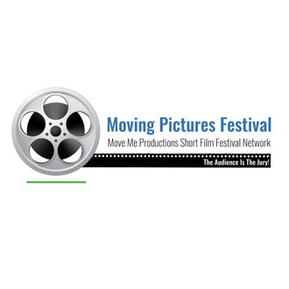  Depth Of Field International Film Festival (Usa)  Brainwash Drive-In/Bike-In/Walk-In Movie Festival (Usa)  Festival Internacional de Cinema de Cerdanya (Espagne)  SanGio's Verona (Italie)  Fright Night Film Fest (Usa)  Festival Internacional de Cine Fantástico de Madrid (Espagne)  Trash Film Festival (Croatie)  Festival Internacional de Cine et Arte (Argentine)  Muestra de Cortometrajes Buenos Aires / París (Argentine)  The Sunrise Film Festival (Canada)  Shiver International Film Festival (Canada) - Semi-Finalist 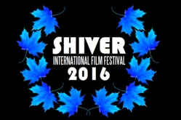  Russian International Horror Film Awards (Russie)  Great Lakes International Film Festival (Usa) – Official Claw Award 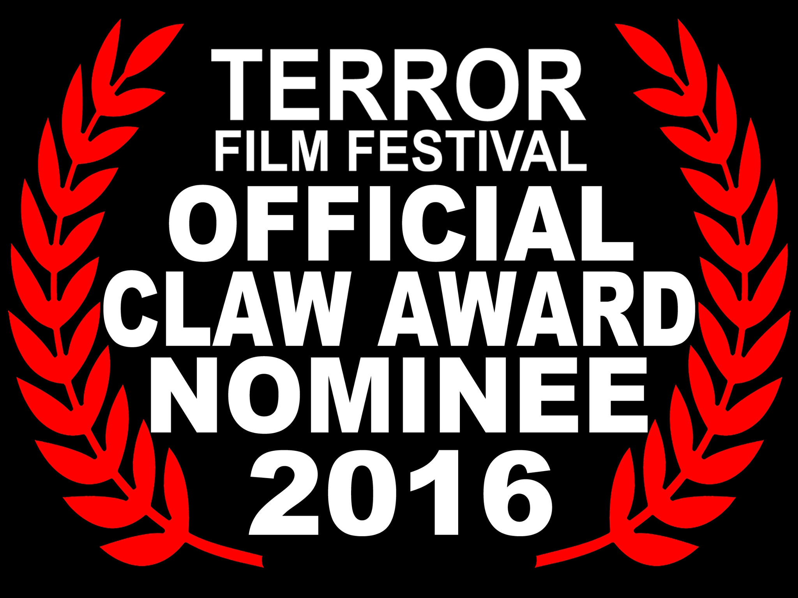  Cannes Latitude Film Festival (Canada)  Upstate NY Horror Film Festival (Usa)  Tula International Film Festival (Fédération de Russie)  Terror Film Festival (Usa)  Chicago International Arthouse FILM FEST (Usa)  Morce-GO Goiás Horror Film Festival (Brésil)  Midwest Horror Shorts Film Festival (Usa)  Festival Internacional del Cortometraje Fic. (Argentine). | Shiver_Laurels_2016.png
 | Shiver_Laurels_2016.png

