REVUE DE PRESSE & COMMUNICATION

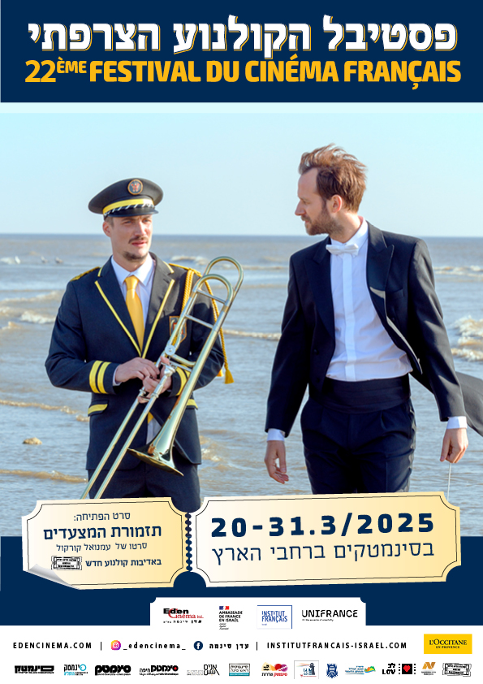

WALLA
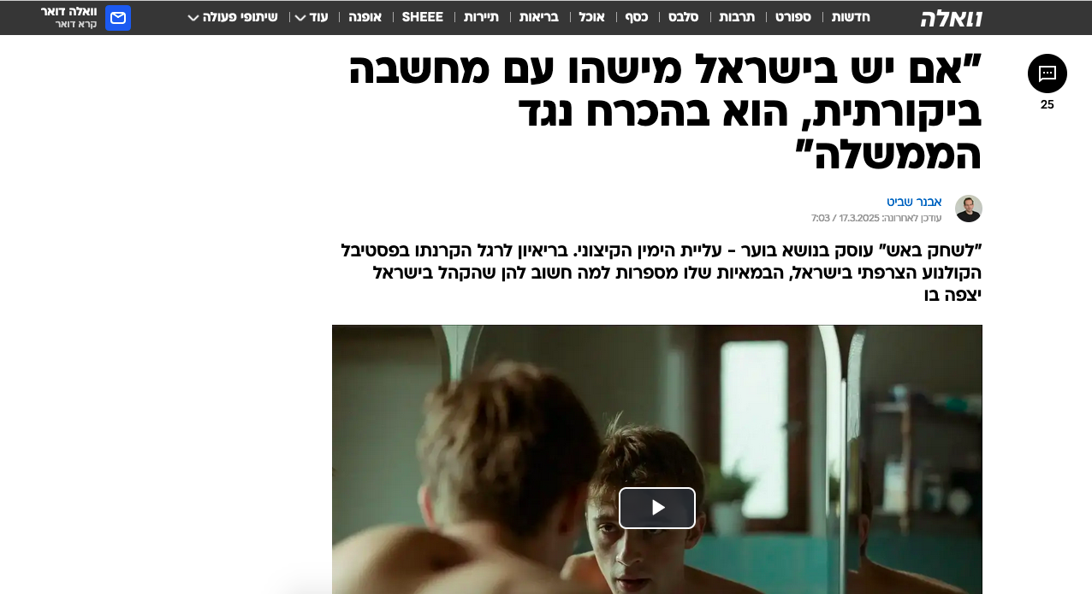

https://e.walla.co.il/item/3734477

YNET

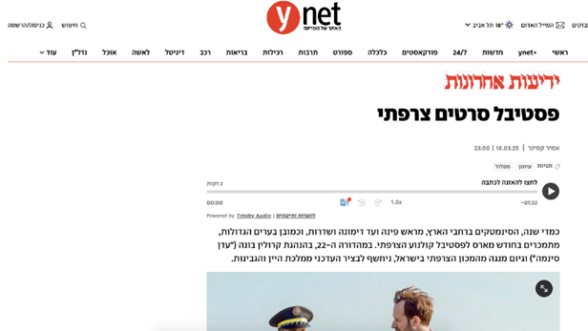
https://www.ynet.co.il/yedioth/article/yokra14290528?utm_source=ynet.app.android&utm_medium=social&utm_campaign=whatsapp&utm_term=yokra14290528&utm_content=Header

TIMES OF ISRAEL

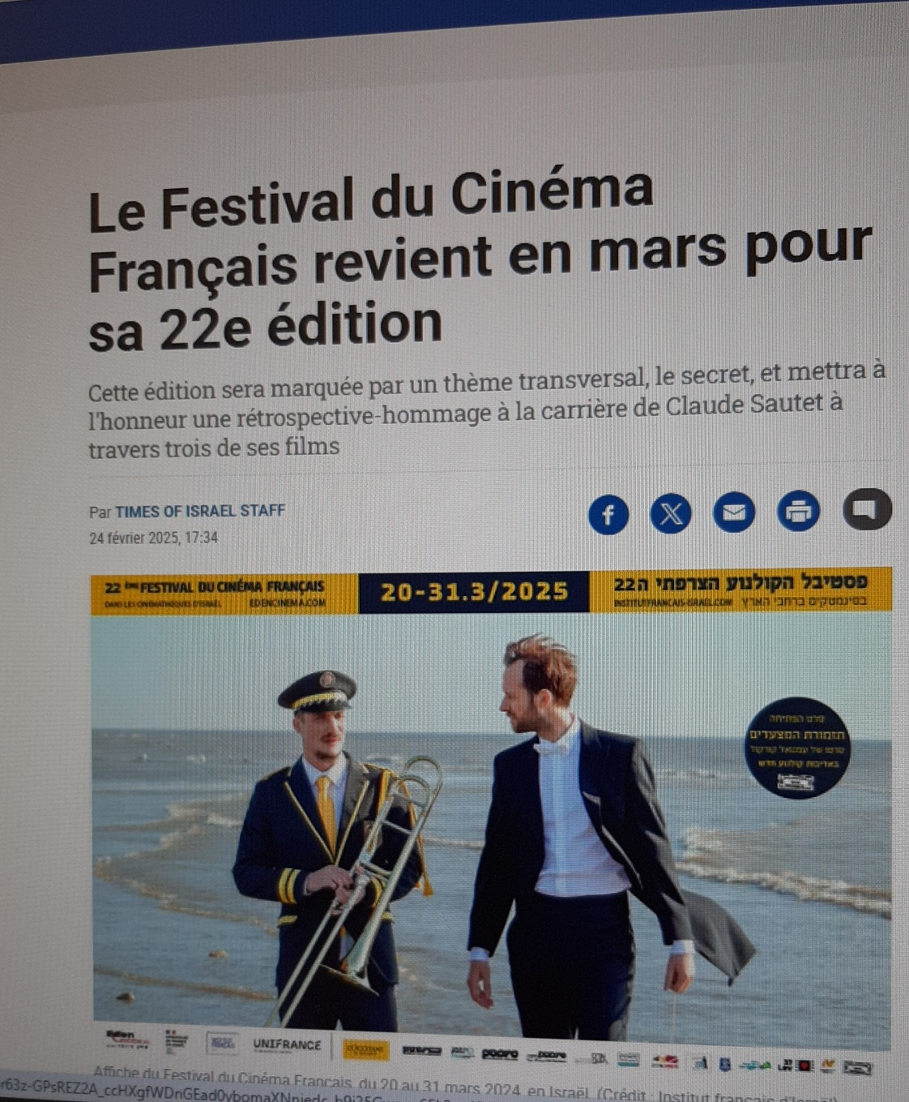

https://fr.timesofisrael.com/le-festival-du-cinema-francais-revient-en-mars-pour-sa-22e-edition/

MAARIV

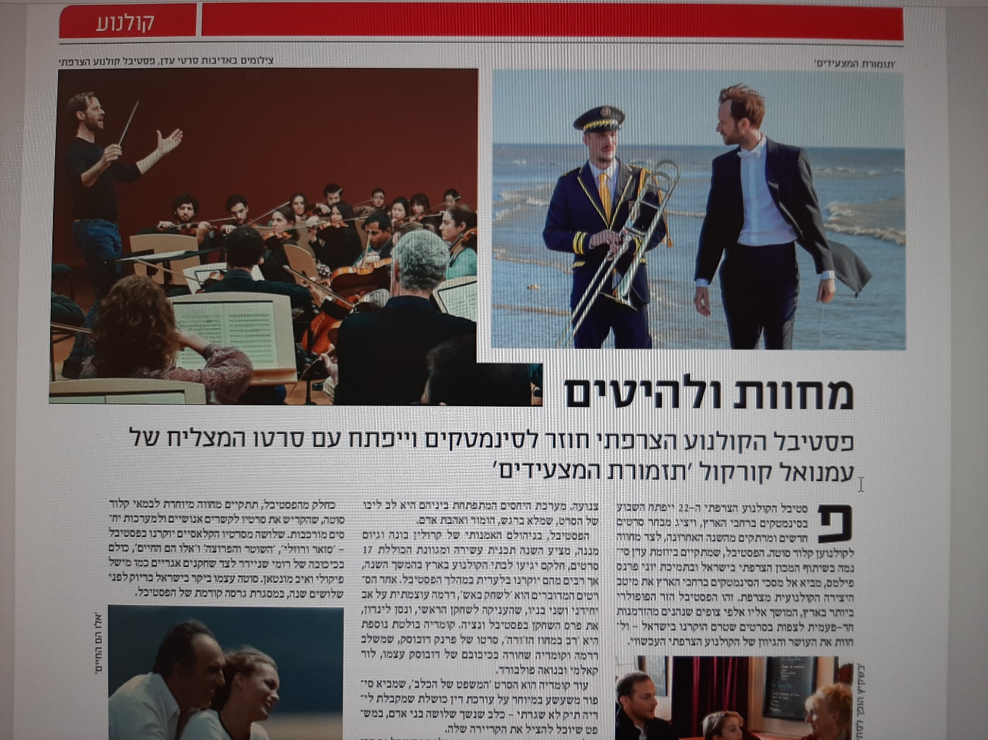

1403TAR 1-16small (1).pdf

ITON TEL-AVIV

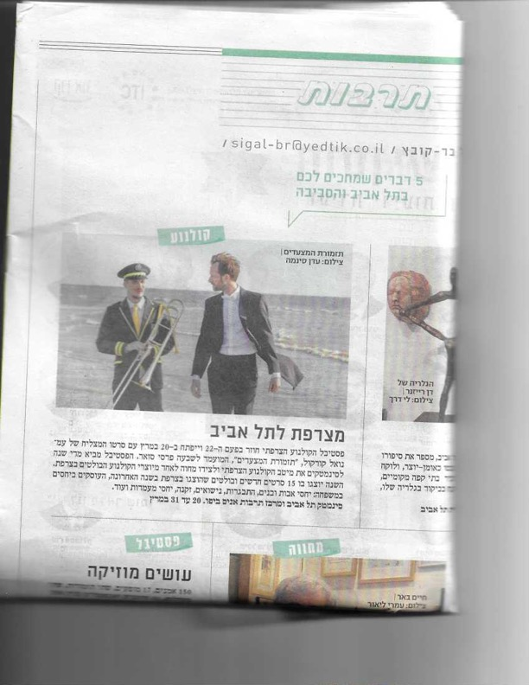

NOVOSTY RUSSIAN NEWSPAPER

Novosty newspaper (in Russian)

HAARETZ
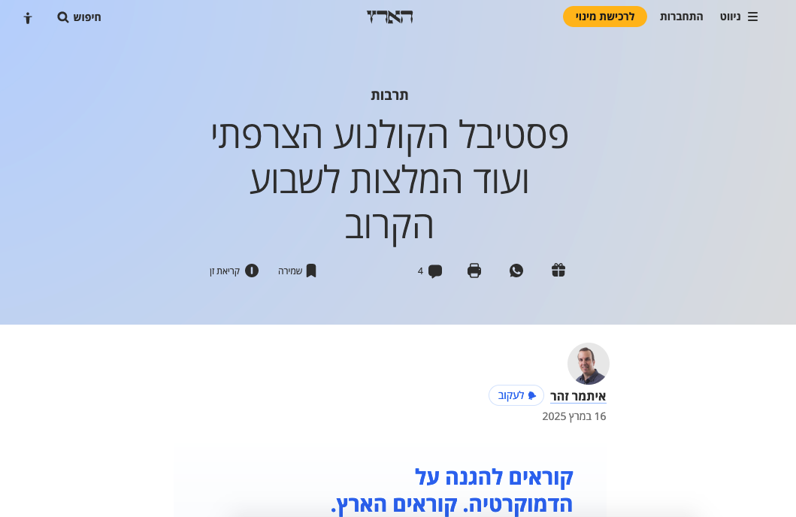
https://www.haaretz.co.il/gallery/2025-03-16/ty-article-timeline/.premium/00000195-7a8e-d88b-afd7-fede8f550000?utm_source=mailchimp&utm_medium=email&utm_content=author-alert&utm_campaign=%D7%90%D7%99%D7%AA%D7%9E%D7%A8+%D7%96%D7%94%D7%A8&utm_term=20250316-06:04

SITE KEDAI LADDAT
אתר כדאי לדעת > פסטיבל הקולנוע הצרפתי ה -22 מגיע אל הסינמטקים
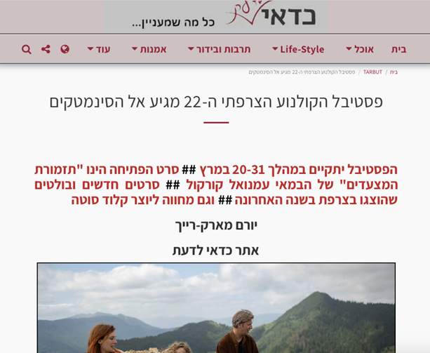

LALI MAGAZINE

https://laliblog.com/2025/02/25/%d7%a4%d7%a1%d7%98%d7%99%d7%91%d7%9c-%d7%94%d7%a7%d7%95%d7%9c%d7%a0%d7%95%d7%a2-%d7%94%d7%a6%d7%a8%d7%a4%d7%aa%d7%99-%d7%94-22/
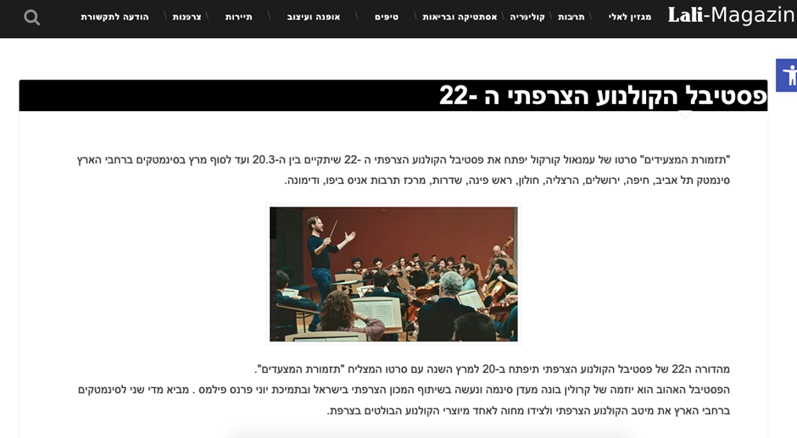

MIDNIGHT EAST
https://www.midnighteast.com/mag/?p=54975
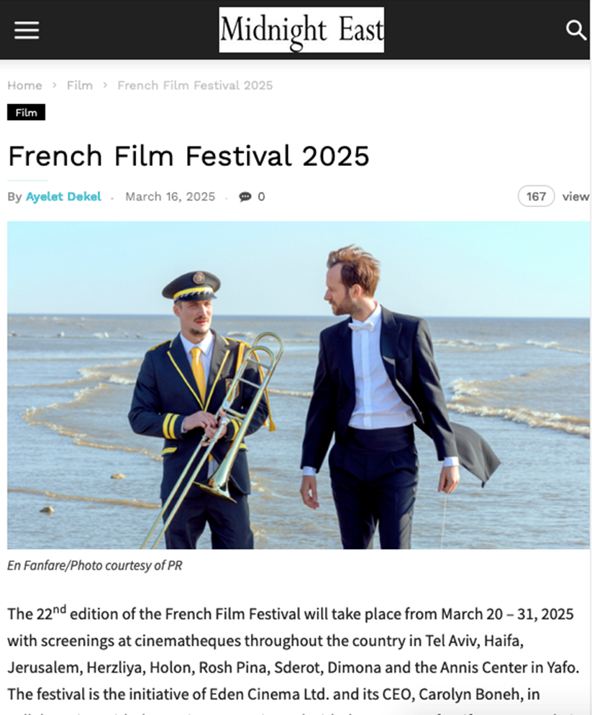

DANY BAR SITE CULTURE AND ARTS MAGAZINE
https://www.danybar.co.il/dany-bars-culture-and-arts-magazine-no-3-2025/
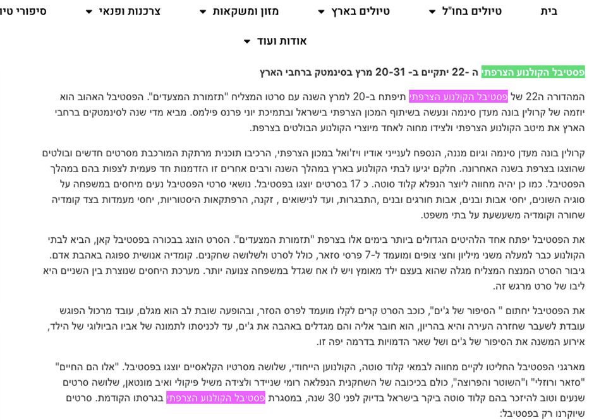
LES FRANCOPHILES ANONYMES
https://www.francophilesanonymes.com/french-cinema-festival-2025/
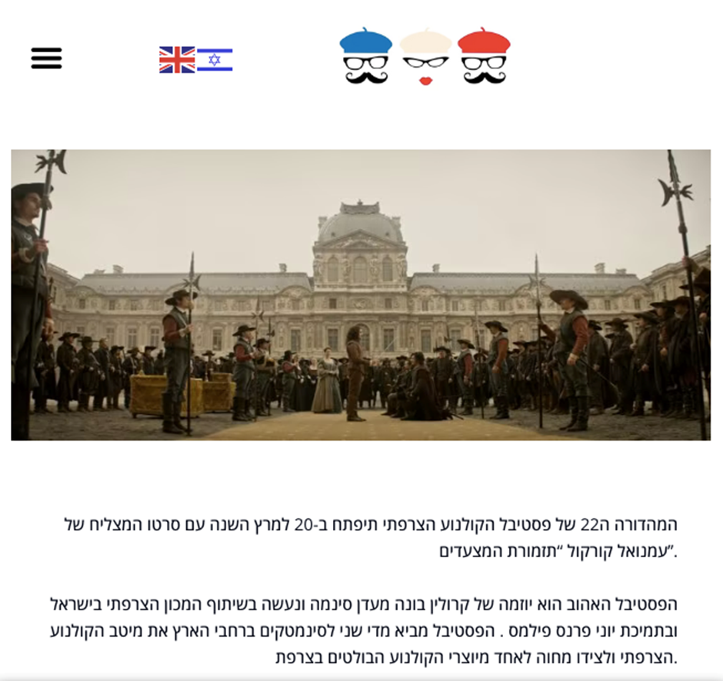

TLV ON LINE
https://tlvonline.co.il/%D7%A4%D7%A1%D7%98%D7%99%D7%91%D7%9C-%D7%94%D7%A7%D7%95%D7%9C%D7%A0%D7%95%D7%A2-%D7%94%D7%A6%D7%A8%D7%A4%D7%AA%D7%99/
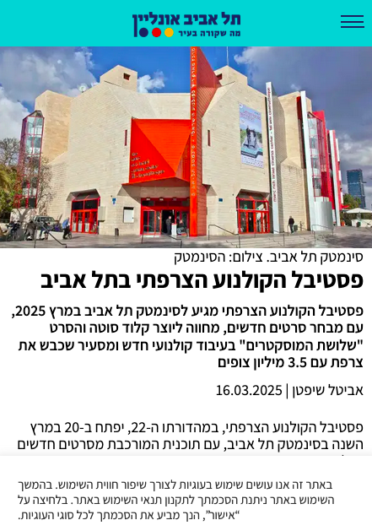

TLV ON LINE

https://www.facebook.com/tlvonline.co.il/posts/%D7%A4%D7%A1%D7%98%D7%99%D7%91%D7%9C-%D7%94%D7%A7%D7%95%D7%9C%D7%A0%D7%95%D7%A2-%D7%94%D7%A6%D7%A8%D7%A4%D7%AA%D7%99-%D7%9E%D7%92%D7%99%D7%A2-%D7%9C%D7%A1%D7%99%D7%A0%D7%9E%D7%98%D7%A7-%D7%AA%D7%9C-%D7%90%D7%91%D7%99%D7%91-%D7%91%D7%9E%D7%A8%D7%A5-2025-%D7%A2%D7%9D-%D7%9E%D7%91%D7%97%D7%A8-%D7%A1%D7%A8%D7%98%D7%99%D7%9D-%D7%97%D7%93%D7%A9%D7%99%D7%9D-%D7%9E%D7%97%D7%95%D7%95%D7%94-%D7%9C/660482219681647
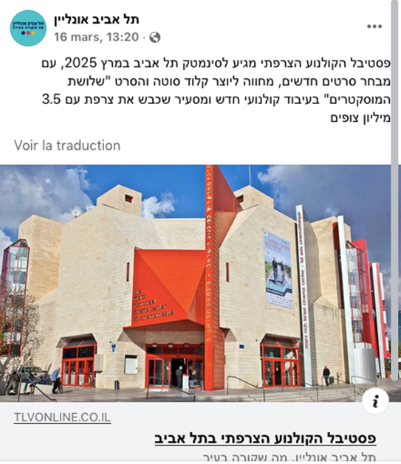

GIRAFA
https://g-rafa.co.il/fff22/
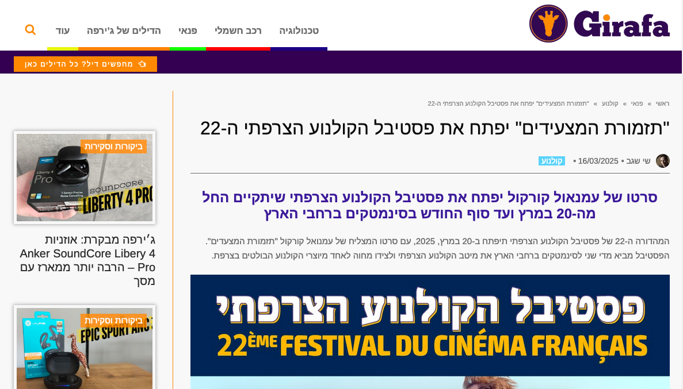

TEL-AVIV NEWS
https://telaviv-news.com/%D7%A4%D7%A1%D7%98%D7%99%D7%91%D7%9C-%D7%94%D7%A7%D7%95%D7%9C%D7%A0%D7%95%D7%A2-%D7%94%D7%A6%D7%A8%D7%A4%D7%AA%D7%99-%D7%97%D7%95%D7%96%D7%A8-%D7%9C%D7%A1%D7%99%D7%A0%D7%9E%D7%98%D7%A7-%D7%AA%D7%9C/
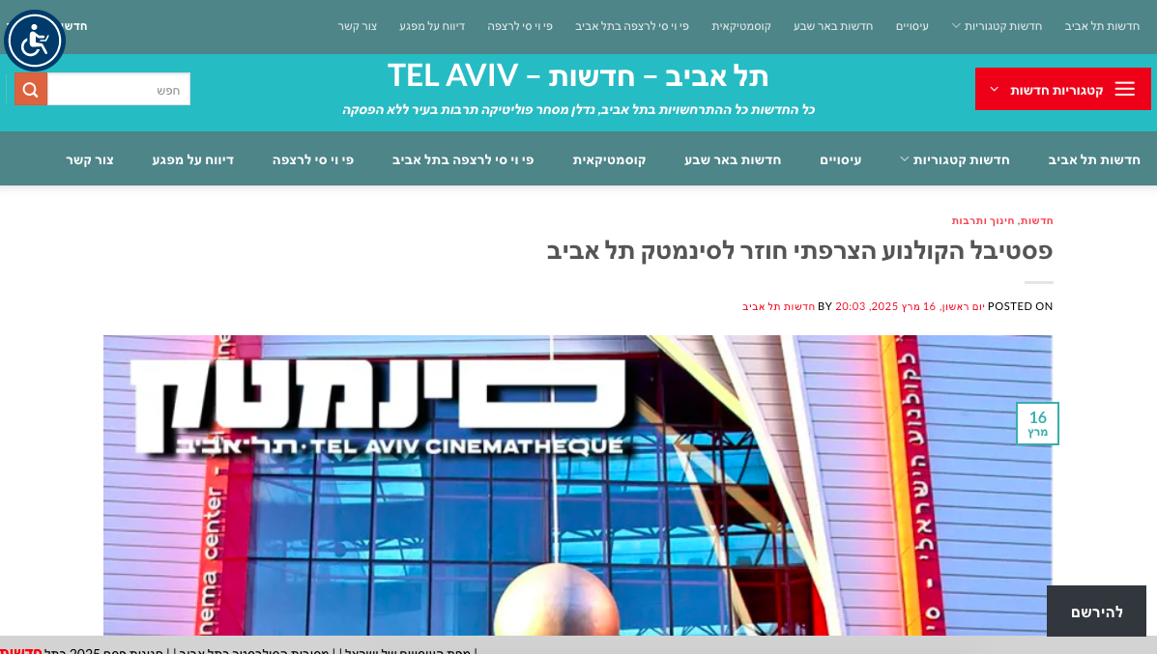

NEWS ISRAEL
https://www.news-israel.net/2025/02/24/%D7%9E%D7%95%D7%9E%D7%9C%D7%A5-%D7%A4%D7%A1%D7%98%D7%99%D7%91%D7%9C-%D7%94%D7%A1%D7%A8%D7%98-%D7%94%D7%A6%D7%A8%D7%A4%D7%AA%D7%99-%D7%91%D7%A1%D7%99%D7%A0%D7%99%D7%9E%D7%98%D7%A7-%D7%AA%D7%9C-%D7%90/
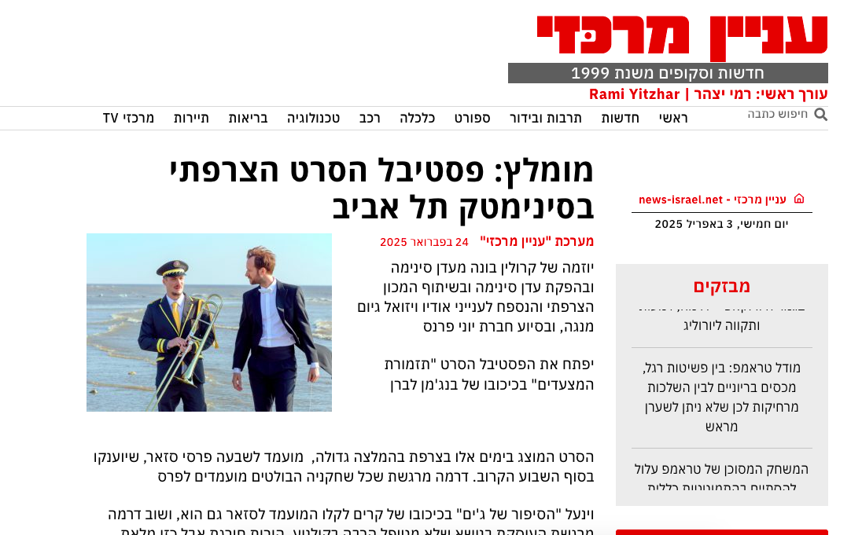

SITE EFITRIGER
https://efitriger.com/2025/02/french-2/
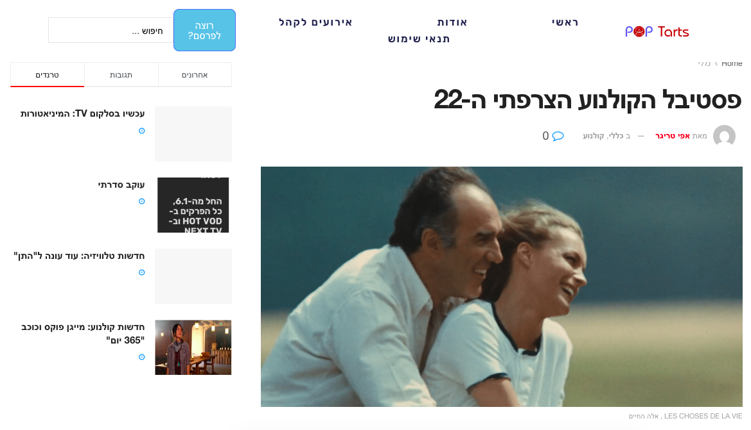

MOTKE
https://www.motke.co.il/%D7%A9%D7%99%D7%97%D7%94_%D7%91%D7%A7%D7%91%D7%95%D7%A6%D7%94/1349811
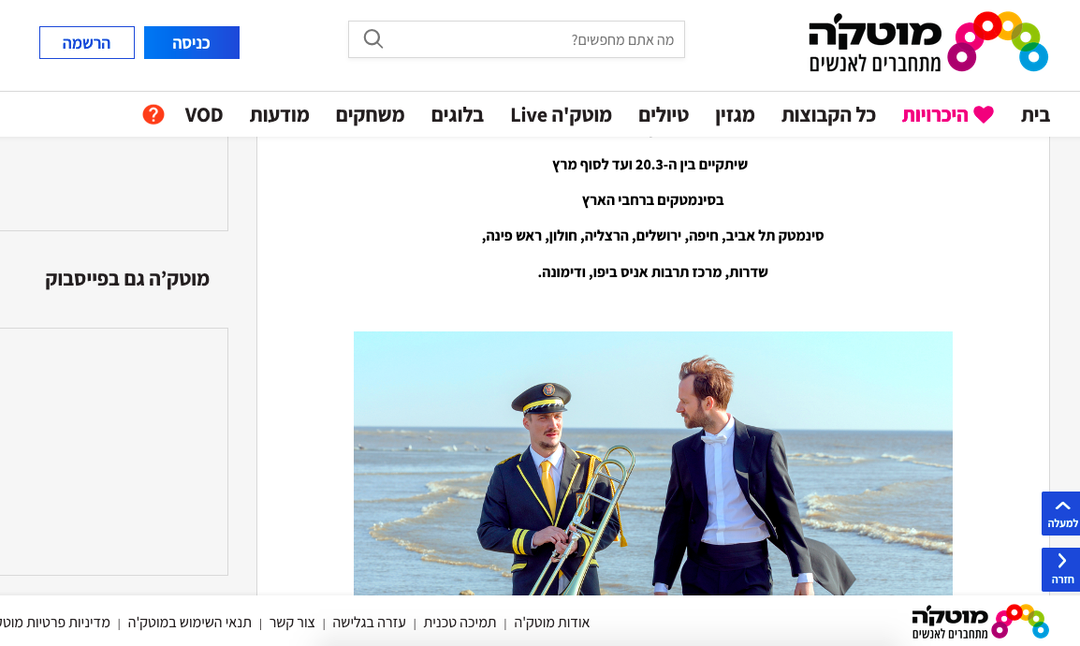

RADIO 106 FM
It’s about a radio program where they spoke about the festival and the films
https://www.facebook.com/share/p/1A7jynNDiD/
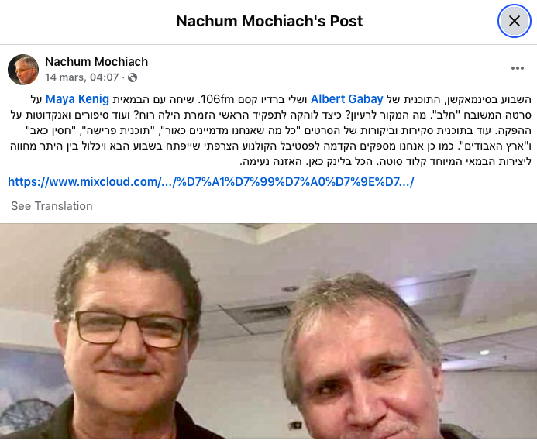

SITE SERET
https://www.seret.co.il/actuality/article.asp?catCase=1&ID=14409&mon=3&yer=2025
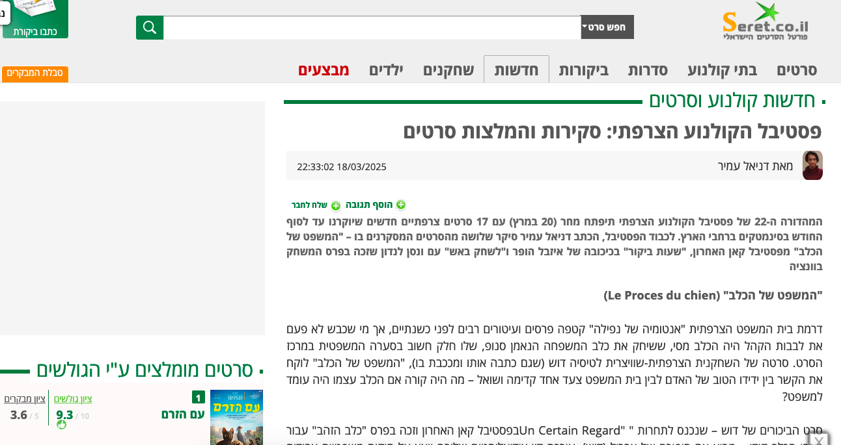
BOULEVARD ROTHSCHILD

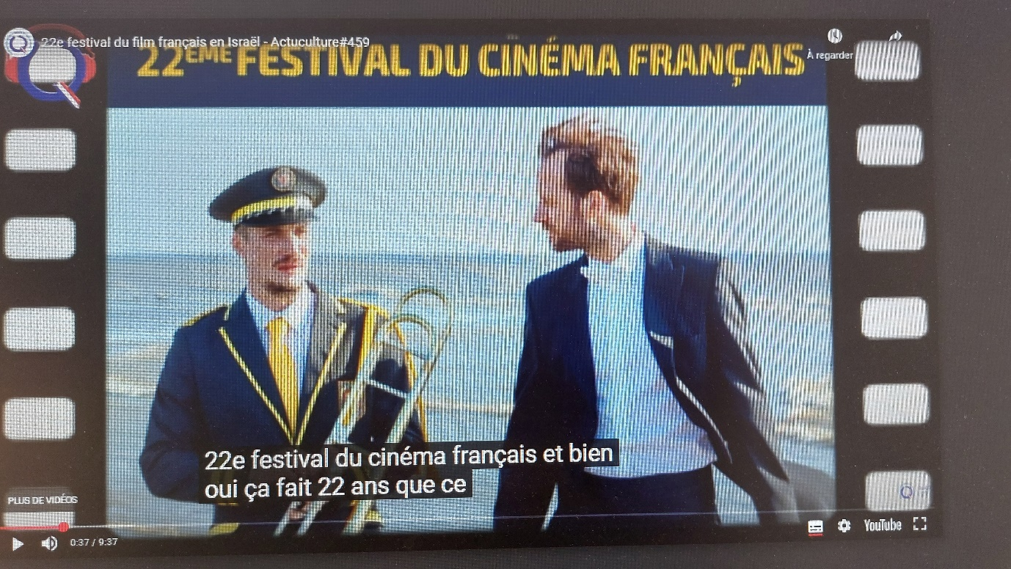
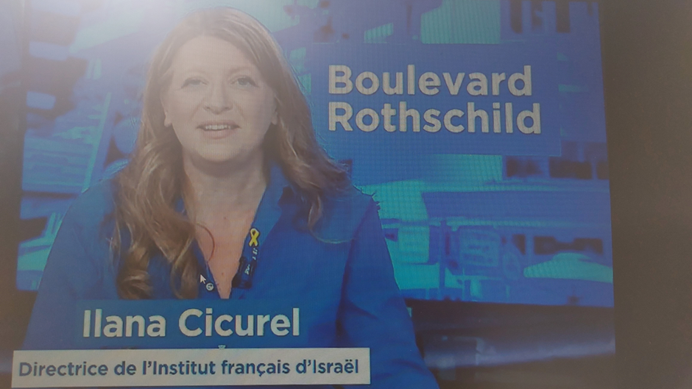

RADIO KAN

RON FOGEL-11 MIN

https://www.kan.org.il/player?itemId=55744&playerType=Radio&programId=9984

QUALITA

https://youtu.be/mRLUjgc-b5U?si=zZ6elFARpKBDw3v5

CALCALIST
In print and on the website
https://www.calcalist.co.il/style/article/rklhe8uhjg

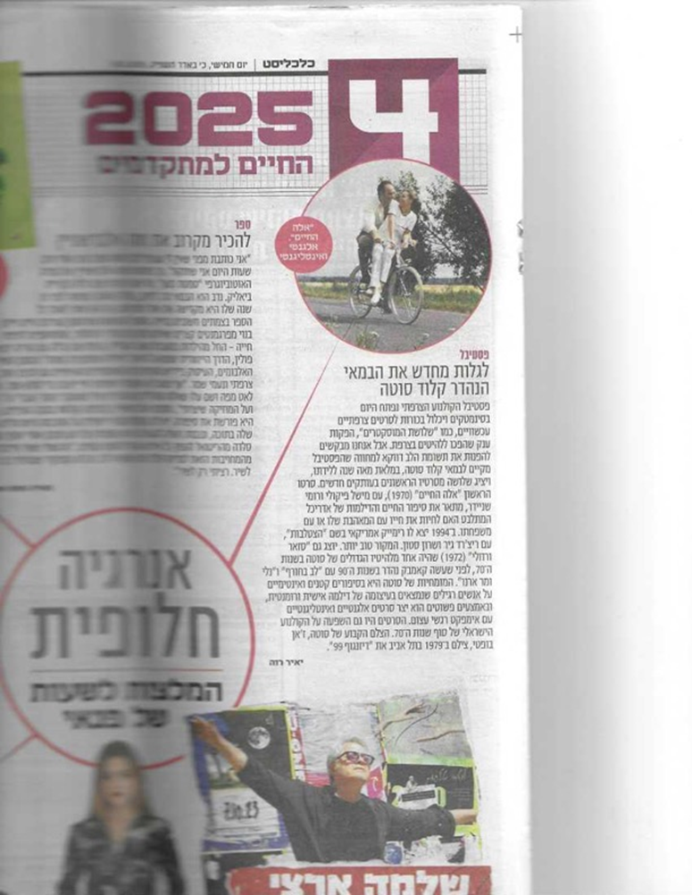

JERUSALEM POST
In print and on the website
https://www.jpost.com/j-spot/article-846606
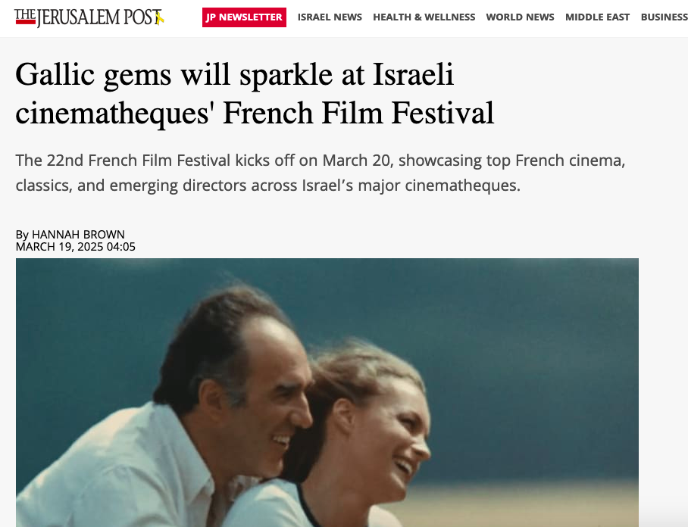

YEDIOTH

MAARIV

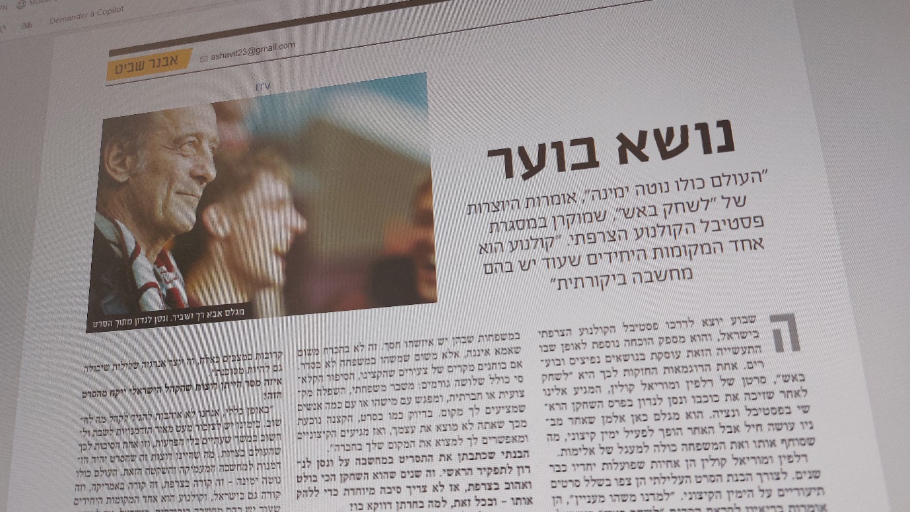

WALLA
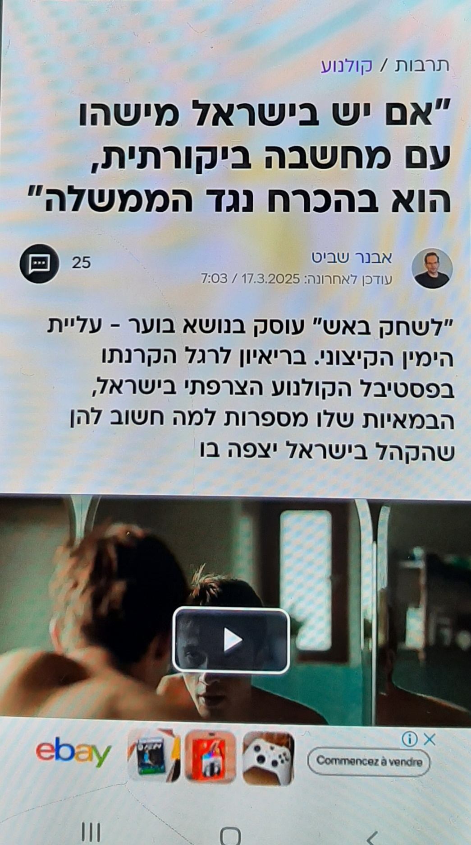

ACTUALITE JUIVE

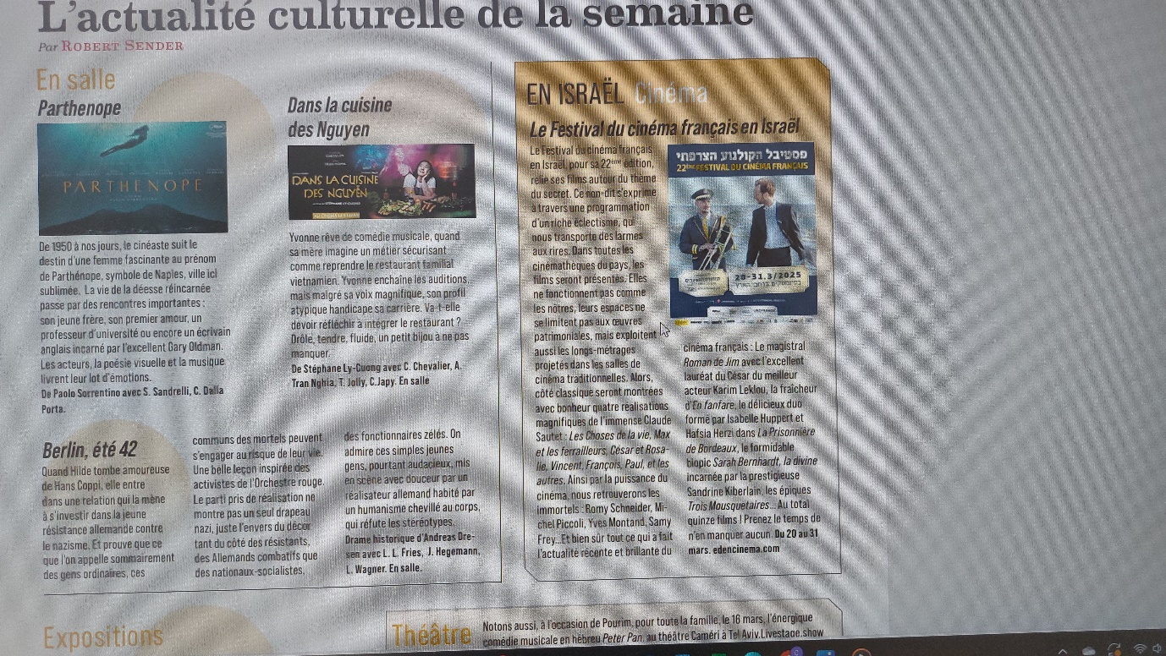

PUB HAARETZ

